## Close Outdoor Air Damper During Unoccupied Periods

### Author

Chris Balbach, PSD Consulting

### Description

This energy efficiency measure (EEM) changes the minimum outdoor air flow requirement of all Controller:OutdoorAir objects associated with airloops and present in a model to represent a value equal to 0 cfm during unoccupied periods. For single zone air systems, unoccupied periods are defined as periods when the any connected thermal zone has less than 5% of the peak specified occupancy. For multi zone air systems, unoccupied periods are defined as periods when the average occupancy of all connected thermal zones is less than 5% of the peak specified occupancy. In addition to outdoor air controller objects attached to airloops, the measure also limits the outdoor air of Four Pipe Fan Coil Units and Unit Ventilator objects if they are present as Zone HVAC equipment objects.

### Modeler Description

This measure loops through all Thermal zones connected to Airloops having an Outdoor Air Controller object, and determines a space-weighted occupancy schedule for each attached thermal zone. The resulting occupancy schedules for each thermal zone are stepped through from hour 0 to hour 24. An airloop is considered occupied during a time period if all thermal zones representing occupancy associated with an air loop have a current occupancy value that is greater than 5% of the annual peak occupancy value. The measure generates a new minimum outdoor air schedule having values of 0 where the all connected thermal zones have less than 5% occupancy and values of 1.0 for all other hours. Finally, the measure examines all Zone HVAC Equipment objects associated with an airloop. If Zone HVAC equipment object of type Four Pipe Fan Coil Unit or Unit Ventilator are found, the occupancy patterns associated with the thermal zone are analyzed and outside air schedules are assigned to allow design outside air levels when the thermal zone is occupied by more than 5 percent of thermal zone peak occupancy, otherwise shut the outside air damper of the Zone HVAC Equipment object completely.

### Use Case Types

New Construction, Retrofit, Model Articulation

### Arguments

No arguments

### Initial Condition Message

The initial model contained {X} Airloops and {Y} Outdoor Air Controller objects for which this measure is applicable.

### Final Condition Message

Outdoor Air Schedules representing closing the outdoor air damper during unoccupied periods have been created for {X} Outdoor Air Controllers.

Not Applicable Messages

* If No AirLoops write N/A message
* If there are Airloops but no outdoor air controllers then write N/A message

### Warning Messages

### None

### Information Messages

Write info message whenever attributes of an outdoor air controller are altered. The message should include the name, object type, previous and new attribute value(s).

### Error Messages

N/A

### Code Outline

1. Loop through all AirLoopHVACs with an Outdoor Air Controller object attached.
   1. Call the create schedule method to create a new occupancy based schedule based on a 5 percent of peak occupancy threshold of all spaces attached to all thermal zones attached to the air loop..
   2. Assign this new OS Schedule object to the ‘minimum outdoor air schedule’ attribute of the OutdoorAirController object associated with the AirLoop object.
   3. Write info message(s).
2. Loop through all thermal zones attached to the object
   1. Test to see if the zone has any ZoneHVACEquipment objects attached. If so
      1. Test to see if the objects are
         1. 4 Pipe Fan Coil Unit
            1. Call the create schedule method to determine a zone population based occupancy schedule
            2. Assign this schedule to the Outdoor Air Schedule attribute of the fan coil object
            3. Write info message
         2. Unit Ventilator
            1. Call the create schedule method to determine a zone population based occupancy schedule
            2. Set the Outdoor Air Control type for the unit Ventilator object to “FixedTemperature”
            3. Assign the new schedule to the Minimum Outdoor Air Schedule attribute of the Unit Ventilator object
            4. Write info message
         3. All other (air system) based Zone HVAC Equipment objects should have a warning message written describing how the OA levels are fixed and cannot be changed.
3. Write N/A message(s)
4. Write Initial and Final Conditions messages

### Tests

Run this model against applicable prototype buildings and test against each qualified object type. Several prototype buildings contain AirLoops with Outdoor Air Controller objects. The measure will be tested against all possible cases.

**This measure applies to All Prototype Models:**

1. **Medium Office**
2. **Large Office**

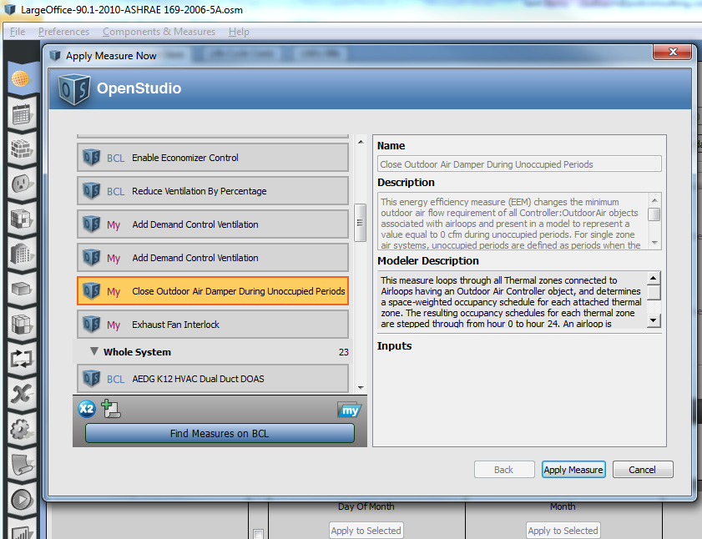

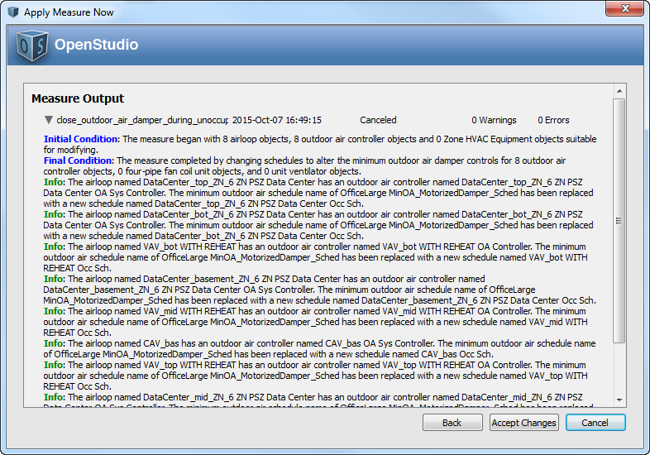

1. **Primary School**

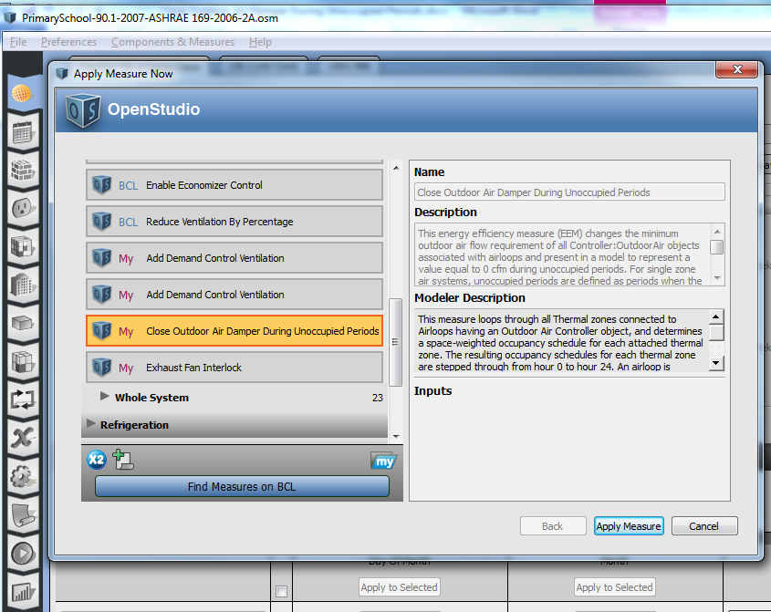

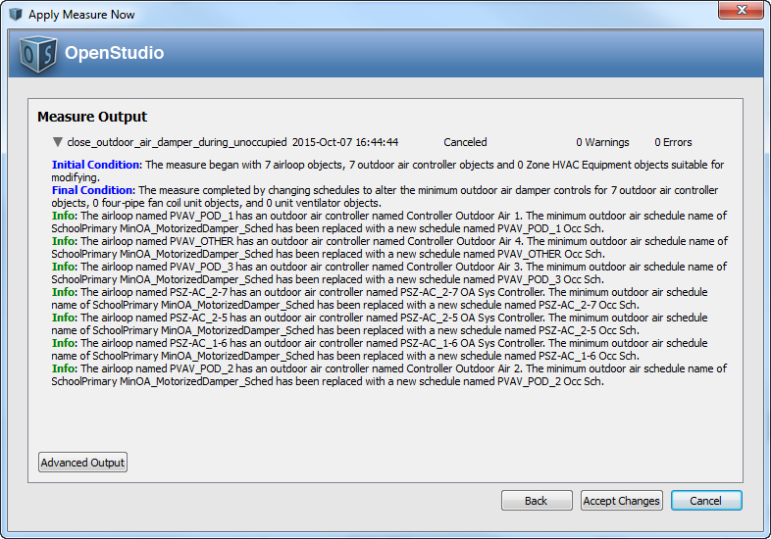

1. **Secondary School**
2. **Outpatient Healthcare**
3. **Large Hotel**

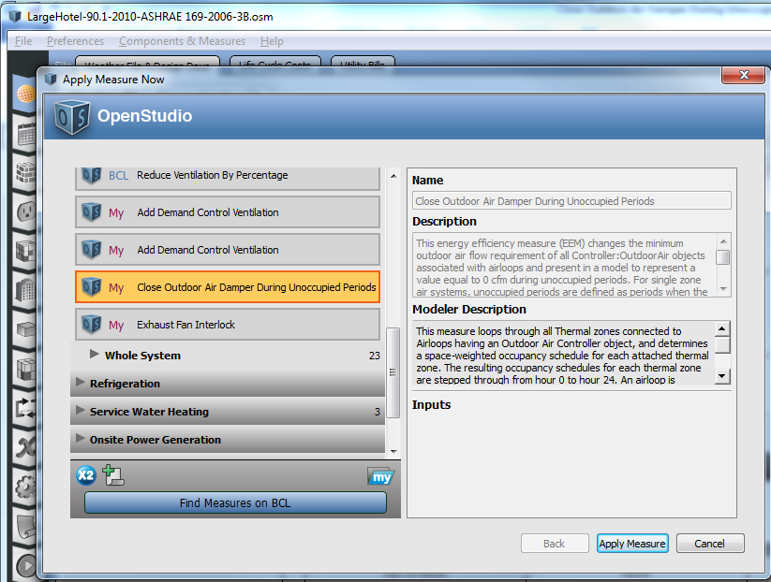

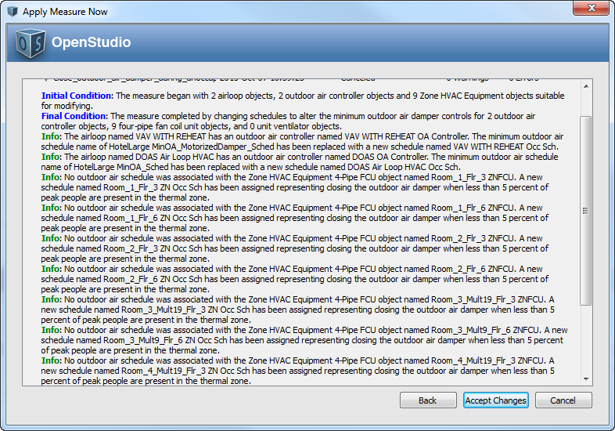

1. **Hospital**
2. **Mid Rise Apartment**
3. **High Rise Apartment**
4. **Small Office**

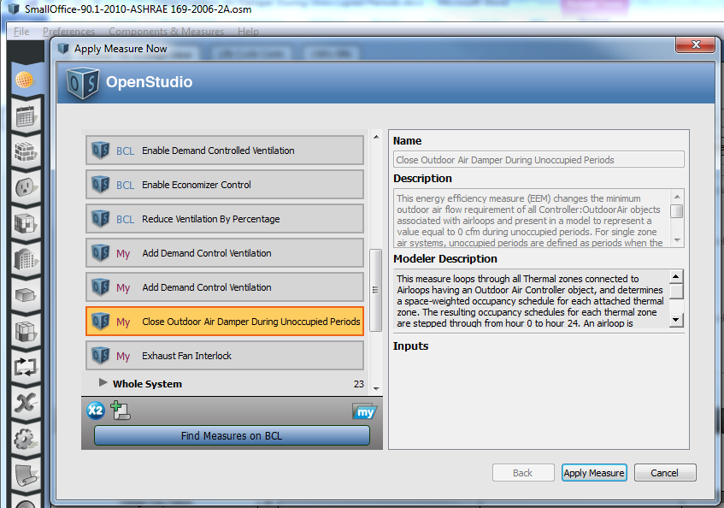

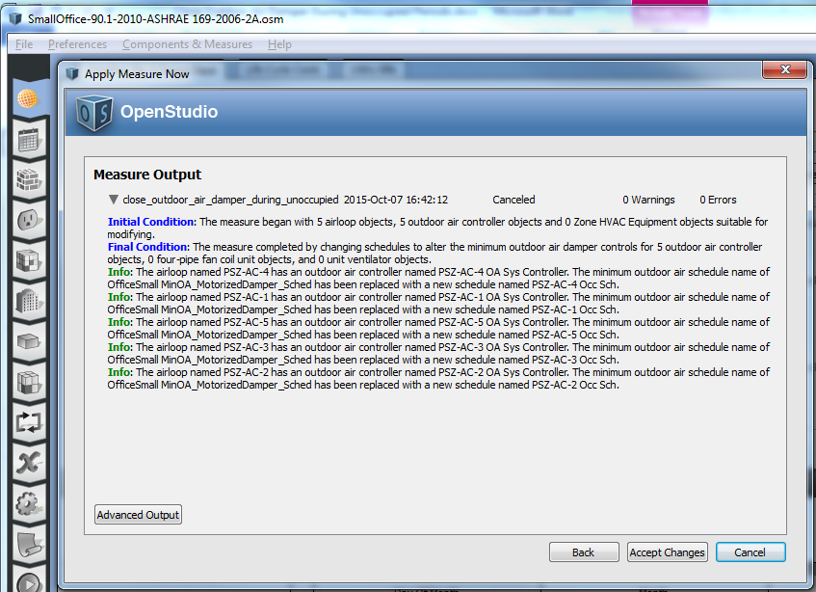

1. **Full Service Restaurant**
2. **Quick Service Restaurant**
3. **Stand Alone Retail**
4. **Strip Mall**
5. **Warehouse (non-refrigerated)**
6. **Small Hotel**

**Test results:**

The delivered measure will include screen shots of the initial, final and info messages as well as screen shots of the OS Application UI showing the object modifications.